Flight CONTROL System

software requirements

**Authors** Frederic BESSIERE

**Last Update** May 23rd, 2007

**Summary:**

This document defines requirements of a flight control system of a plane.

***Table Of Contents***

1. Introduction 3

2. Requirements 3

2.1 Flight Control Unit 3

2.1.1 Interface 3

2.1.2 Flight Controller 3

2.1.3 Alarm Manager 4

2.1.4 Display Logic 4

2.2 Primary Flight Display 5

2.2.1 Display Content 5

2.2.2 Display Colors 5

# Introduction

The Flight Control System is used to automatically control flight commands to maintain the plane in a desired state. It is composed of two parts, a flight control unit and a primary flight display.

# Requirements

## Flight Control Unit

### Interface

The following diagram resumes the FCU inputs and outputs:

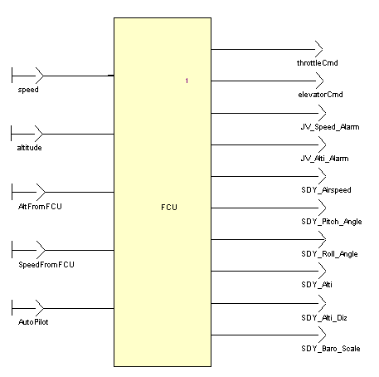

### Flight Controller

Speed and altitude of the plane should be regulated.

Plane actuators, the throttle command and the elevator angle, should be calculated based on the pilot settings and the measures performed by the sensors.

#### Altitude error contribution

FCU_01

Altitude contribution is corrected with a gain altKp.

FCU_04

The altitude contribution is centered on 50%

#### Speed error contribution

FCU_02

Speed contribution is regulated with a PI, and transformed into an angle using a lookup table.

#### Elevator Command

FCU_03

The value of the elevator command is the corrected altitude error contribution minus the corrected speed error contribution.

#### Throttle Command

FCU_05

The value of the throttle command is the corrected altitude error contribution plus the corrected speed error contribution

### Alarm Manager

The alarm manager warns the pilot when the plane is reaching its settings

#### Altitude Alarm

FCU_06

Altitude Alarm is triggered if the measured altitude moves away from the altitude set point more than alarmAltThreshold, during more than alarmAltTimer time cycles

#### Speed Alarm

FCU_07

Speed Alarm is triggered if the measured speed moves away from the speed set point more than alarmSpeedThreshold, during more than alarmSpeedTimer time cycles

### Display Logic

FCU_08

The FCU shall provide information about the flight: speed, altitude with hundredth, pitch angle, and roll angle.

## Primary Flight Display

### Display Content

PFD_01

The display shall indicate the Heading value on a scale graduated from 0 to 360.

PFD_02

The display shall indicate the Vertical Speed on the left side.

PFD_03

The display shall indicate the Altitude on the right side.

### Display Colors

PFD_04

The general background of the display shall be blackX.

PFD_05

The background of the Vertical Speed indicator shall be grey.

PFD_06

The background of the Altitude indicator shall be grey.